OCEANA COUNTY 4-H MARKET LIVESTOCK
EDUCATIONAL NOTEBOOK/RECORD

LAMB PROJECT - 2025

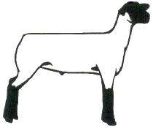
As a member of the 4-H Market Livestock Lamb project you are required to submit your records as part of an educational project notebook in order to sell your animal at the 4-H Market Livestock Sale. This notebook must be shown to the Oceana County 4-H Market Livestock Committee's Weighmaster at the time of weigh-in and then entered by you in the Educational Notebook Division of the Oceana County Fair on Entry Day.

AGE: ________

Remember: The age you enter depends on how old you are or will be on Jan. 1, 2025

Number of years in project: _______

Use this sheet as the first page of your project record book. Fill it out completely.
Please print or type neatly.

NAME_______________________________________________________________________

4-H CLUB_____________________________________________________________________

BREED________________________________LAMB’S NAME__________________________

DATE OF BIRTH___________________ DATE RECORD STARTED_____________________

LOCATION WHERE ANIMAL IS RAISED __________________________________________



JUDGE’S SCORE/COMMENT SHEET

(PLEASE DO NOT REMOVE, PLACE THIS SHEET IN SHEET PROTECTOR OR GLUE TO COVER). This sheet must be kept free for the judge to write their comments.

This sheet should help each 4-H’er understand their ribbon placing.

A. Specific educational value or worth

___ All questions were answered completely

___ All calculations were correct

___ Calculations were incorrect

___ Questions were not completely answered

___ Questions were not answered (missed questions)

B. Notebook contains all project records

___ Notebook contained all project records and were fully completed

___ Notebook contained additional project related information (research

materials etc.)

___ Project records were incomplete

___There was no additional project related information

C. Accuracy, neatness and general appearance

___Notebook was neat in appearance (typed/hand printed)

___Notebook pages were clean and stain free

___Notebook pages were in order and complete

___Notebook pages were out of order and missing pages

___Notebook was difficult to read and messy

__Notebook had wrinkled and stained pages

Other Comments: ______________________________________________________

____________________________________________________________

____________________________________________________________

4-H MARKET LIVESTOCK LAMB NOTEBOOK- 2025

TABLE OF CONTENTS

Please keep your notebook in Table of Contents order.

- GENERAL GUIDELINE INFORMATION

- JOURNAL OF CARE

- PROJECT INFORMATION

- PROJECT KNOWLEDGE
  - Lamb Parts Identification
  - Wholesale Cuts

- MY PROJECT INFORMATION
a) Your Project
b) 4-H Info

- BUYERS NAMES

- PICTURES OF YOUR PROJECT (1 page)

- NON-CLUB/CLUB POINTS SHEETS

APPENDIXES (OPTIONAL):

- PICTURES OF YOUR PROJECT (additional pictures)
- FEED INFORMATION (example: feed labels etc.)
- ADDITIONAL INFORMATION ABOUT YOUR PROJECT
  - Information you found in reference materials
  - Worksheets done with your 4-H Club
  - Information you located off the internet
  - Information gathered from your feed representative
  - Any other information
* Include notes as to why you researched this information and found it
Valuable, link it to your project if possible.

Note: Reference materials used for the specific project knowledge include:

b. Your Sheep – A Kid’s Guide to Raising and Showing
c. 4-H Skills for Life Animal Science Series – Lambs 1, 2 & 3
d. Kansas State 4-H Online
e. Lamb Resource Book (The Ohio State University 4-H)

2025- Lamb Record Book Page 1

This record is part of your 4-H Market Lamb Project work. By keeping records up to date you will be able to see how much progress you make as you set goals and work to accomplish them. Write neatly and clearly. Feel free to add extra pages.

PROJECT PICTURES

Pictures are a required part of this notebook. Taking pictures of your project animal throughout the project will indicate how your animal has grown and developed. Add pictures to your notebook on a separate piece of paper.

SCORING CRITERIA

The following breakdown will be used during the judging process of all market livestock notebooks.

A. Specific educational value or worth 30%

B. Creative way of showing what has been learned 10%

C. Notebook contains all project records 50%

D. Accuracy, neatness and general appearance 10%

The Oceana County 4-H Market Livestock Committee encourages 4-H Leader and parent assistance with your project and project notebook. If you should have any questions, please contact the MSU Extension Office.

I, ____________________________ assisted ________________________ in
Parent/Leader/Adult Name 4-Her’s Name
understanding the questions and writing the answers. All answers are those of the 4-Her.

____________________________________
Signature of person helping with notebook
If written help was needed

2025- Lamb Record Book Page 2

JOURNAL OF CARE SUMMARY

The 4-H Market Livestock Committee is requiring all 4-H Market Livestock members to complete the “Journal of Care” so the judge may see the time, effort and care you have put into learning about your animal. What did you do to keep your animal healthy and prepare them for fair?

** Include things such as walked, fed, washed, clipped, trimmed, foot care, health practices, medicines, general maintenance (cleaning living & feed area), halter broke, training, had vaccinated, etc. **please attach additional sheet for more room.

_____________________________________________________________________________

_____________________________________________________________________________

_____________________________________________________________________________

______________________________________________________________________________

______________________________________________________________________________

______________________________________________________________________________

______________________________________________________________________________

______________________________________________________________________________

______________________________________________________________________________

______________________________________________________________________________

______________________________________________________________________________

______________________________________________________________________________

______________________________________________________________________________

______________________________________________________________________________

______________________________________________________________________________

______________________________________________________________________________

I,_______________________________, do attest and certify that this 4-Her has cared for
(property owner name-please print-if parent put parent’s name)

animal in a responsible manner while housed on my property. I also understand that integrity & responsibility are important to this 4-H experience.

____________________________________ ________ _________________
Signature of Property Owner or Parent Date
If housed on own property.

2025- Lamb Record Book Page 3

PROJECT INFORMATION

The start of the project will be the date the 4-Her placed the animal on feed, not any later than June 1st of the current year. The end of the project will be weigh-in day at the Fair.

Project Start Date ______________ Project End Date ________________ Fair Haul In

What month was your lamb born? __________________________

Please complete the following chart about your project.

4-H Ear Tag  Number | Breed | Gender | Date of Purchase | Price or value | Estimated Starting Weight | Ending/FinalWeight  (FW) | Total Pounds Gained
Note: Total pounds gained = ending weight – starting weight

MONTHLY FEED RECORD & EXPENSES

Month | Type of feed used-  (grain, roughage, etc.) | Supplements  (if any used) | Amount  (indicate lbs., bales etc.) | Cost of feed used for the month
April
May

2025- Lamb Record Book Page 4

MONTHLY FEED RECORD & EXPENSES (cont.)

Month | Type of feed used-  (grain, roughage, etc.) | Supplements  (if any used) | Amount  (indicate lbs., bales etc.) | Cost of feed used for the month
June
July

August
Column Totals

Total Feed Costs for Project $________________

2025- Lamb Record Book Page 5

EXPENSES OTHER THAN FEED

The 4-H Market Livestock Committee would like you to keep a running list of all of your expenses -- veterinary charges, bedding, insecticides, trucking, insurance, interest paid on money borrowed, housing etc. Even if your parents pay for these items, figure out how much your animal needs and or uses as this is an expense of YOUR project.

 | Vet  Charges | Bedding | Insecticides | Equipment | Trucking | Housing/Rent | Shearing or  Clipping | Advertising/  Marketing | Miscellaneous (specify) | Buyer Recognition | MONTHLY TOTAL
APR
MAY
JUNE
JULY
AUG
TOTALS

2025- Lamb Record Book Page 6

PROJECT EFFICIENCY INFORMATION

(using figures from page 3,4 and 5)

Value of Animal at Time of Purchase = ___________

__________________ ÷ ______________ = __________________________
Total lbs. of Gain Days on Feed Average Daily Rate of Gain
(from page 4)

_______________ ÷ __________________ = __________________________
Total Feed Cost Total lbs. of gain Feed Cost per lbs. of Gain

______________________÷__________________=___________________________
Total lbs. of feed fed Total lbs. of gain Lbs. of Feed Fed per lb. of Gain

_________________ + ______________ + ______________ = ______________ (TE)
Total Feed Expense Cost of Animal Other Expenses Total Project Expense

Lambs are sold by the pound at a Large Animal Sale Auction. Find out what bid price (per lb.) you need to get at the Large Market auction to breakeven (BE) on your market lamb project.

__________________÷____________________= ____________________________
Total Expenses (TE) Final Weight (FW) Break Even Price (BE)
(or total cost per lb. to raise your animal)

What is the current selling price of lamb (per lb.)? _____________________________

Where did you find the current selling price? ________________________________
(if your source was a person, ask them where they got this information)

Would you have been able to make a profit selling on the open market? __________

Why or why not? _______________________________________________________

_____________________________________________________________________

_____________________________________________________________________

2025- Lamb Record Book Page 7

PROJECT KNOWLEDGE
PARTS OF THE LAMB IDENTIFICATION
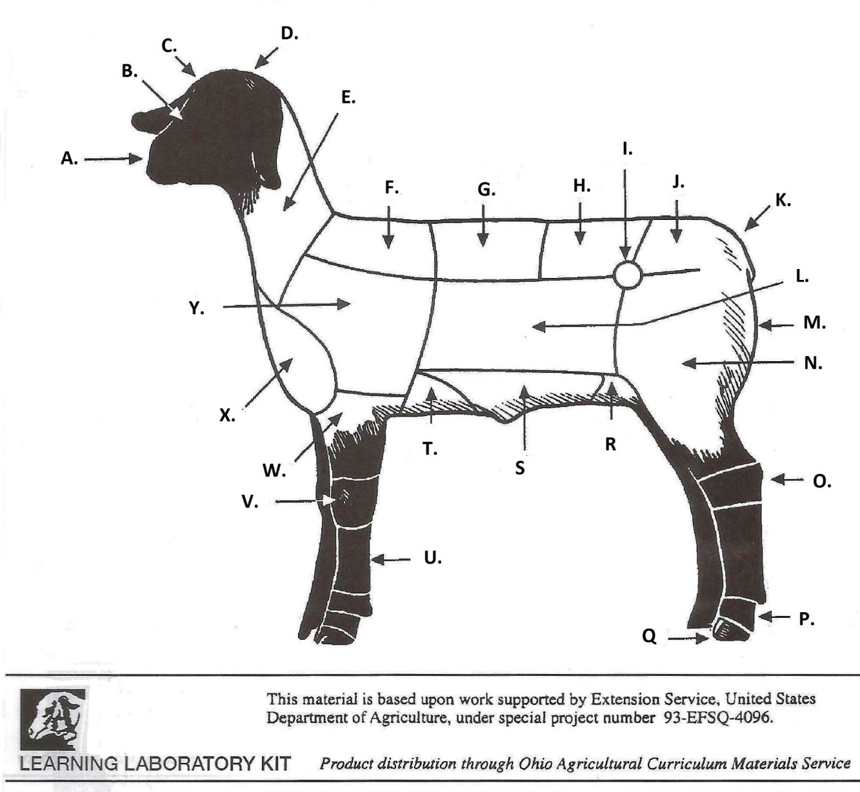
___ Back or Rack ___ Belly ____ Breast or Brisket

___ Cannon ___ Dock ____ Face

___ Fore Arm ___ Fore Flank ____ Forehead

___ Hips ___ Hock ____ Hoof

___ Knee ___ Leg ____ Loin

___ Middle ___ Muzzle ____ Neck

___ Pastern ___ Poll ____ Rear Flank

___ Rump ___ Shoulder ___ Top Shoulder

___ Twist

2025- Lamb Record Book Page 8

KNOWING YOUR LAMB-PROJECT KNOWLEDGE

WHOLESALE CUTS

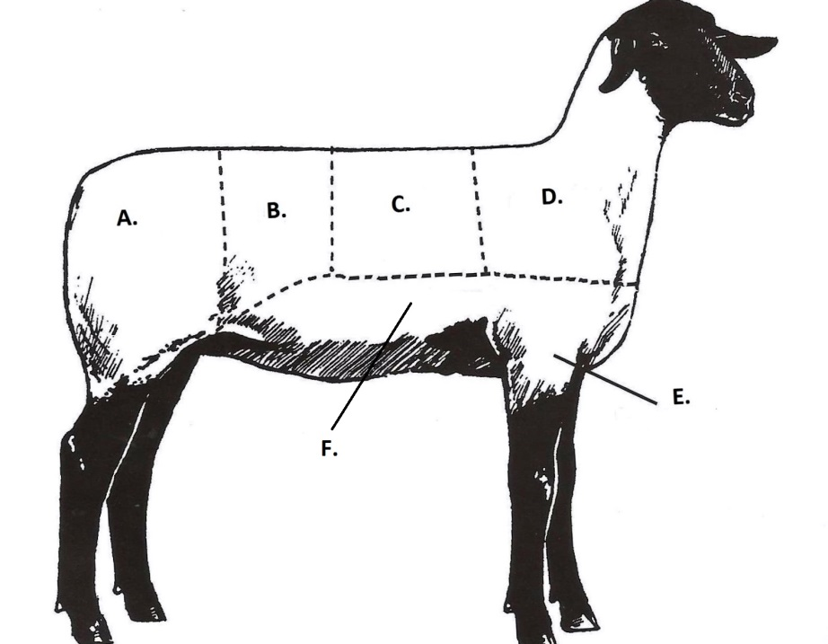

Write the letter that corresponds to the correct Wholesale Cut:

WORD LETTER

Shoulder _____

Foreshank _____

Leg _____

Loin _____

Breast _____

Rack _____

2025- Lamb Notebook Page 9

your project

Please describe your year with your project. Things you can include: How did you select your lamb, are you happy with your project, the best and worst features of your lamb project, and would you do the project again.

______________________________________________________________________

______________________________________________________________________

______________________________________________________________________

______________________________________________________________________

______________________________________________________________________

______________________________________________________________________

______________________________________________________________________

______________________________________________________________________

______________________________________________________________________

______________________________________________________________________

______________________________________________________________________

______________________________________________________________________

______________________________________________________________________

______________________________________________________________________

______________________________________________________________________

______________________________________________________________________

______________________________________________________________________

______________________________________________________________________

2025- Lamb Notebook Page 10

4-H INFORMATION
The 4-H Pledge

I pledge…..

___________________________________________________________________________________,

___________________________________________________________________________________,

___________________________________________________________________________________,

___________________________________________________________________________________,

___________________________________________________________________________________,

___________________________________________________________________________________.

The 4-H MOTTO:______________________________________________________

List 1 way that you helped or taught others this year:

_____________________________________________________________________

_____________________________________________________________________

________________________________________________________________________________________________________

________________________________________________________________________________________________________

POTENTIAL BUYERS NAMES

As part of your 4-H Market Livestock Project, you must personally contact at least five potential buyers before the Oceana County Fair. You are encouraged to seek two new buyers that have not been asked or submitted before. You also must have at least three different buyers than those of your siblings in the market livestock project. Please confirm with your buyers their accurate mailing address (example: post office box vs. a street address). The information on page 11 must be completed and taken to the Oceana County MSU Extension Office on or before the due date where it will be copied and used to send out letters to your potential buyers. This page will remain in your notebooks. This is a Market Livestock Committee rule. Failure to comply will result in not being able to sell your animal in the 4-H Market Livestock Sale.

2025-Lamb Record Book Stamp _______________
PAGE 11 Staff _______________

4-H MARKET LIVESTOCK POTENTIAL BUYER’S LIST
LAMB PROJECT

Name______________________________ Club_________________________
Please print business names and complete addresses clearly.

1. Contact Name ____________________________________________________

Business Name ____________________________________________________

Mailing Address _________________________City_________________Zip_____

Phone _______________________ After Hours Phone______________________
Mailing Preference (Please Check One): Email ____ Postal Delivery ____

Email ____________________________________________________________

Signature__________________________________________________________

2. Contact Name ____________________________________________________

Business Name ____________________________________________________

Mailing Address _________________________City_________________Zip_____

Phone _______________________ After Hours Phone______________________
Mailing Preference (Please Check One): Email ____ Postal Delivery ____

Email ____________________________________________________________

Signature__________________________________________________________

3. Contact Name ____________________________________________________

Business Name ____________________________________________________

Mailing Address _________________________City_________________Zip_____

Phone _______________________ After Hours Phone______________________
Mailing Preference (Please Check One): Email ____ Postal Delivery ____

Email ____________________________________________________________

Signature__________________________________________________________

(Must be stamped by the MSU Extension Office)

2025-Lamb Record Book Stamp _______________
PAGE 12 Staff _______________

If you would like to contact additional buyers you can use this page. If not please throw this page out.

Contact Name ____________________________________________________

Business Name ____________________________________________________

Mailing Address _________________________City_________________Zip_____

Phone _______________________ After Hours Phone______________________
Mailing Preference (Please Check One): Email ____ Postal Delivery ____

Email ____________________________________________________________

Signature__________________________________________________________

Contact Name ____________________________________________________

Business Name ____________________________________________________

Mailing Address _________________________City_________________Zip_____

Phone _______________________ After Hours Phone______________________
Mailing Preference (Please Check One): Email ____ Postal Delivery ____

Email ____________________________________________________________

Signature__________________________________________________________

Contact Name ____________________________________________________

Business Name ____________________________________________________

Mailing Address _________________________City_________________Zip_____

Phone _______________________ After Hours Phone______________________
Mailing Preference (Please Check One): Email ____ Postal Delivery ____

Email ____________________________________________________________

Signature__________________________________________________________

2025- Lamb Notebook Page 13

YOUR PROJECT PICTURES

(Please use this page for your project pictures. If you have more than 1 page of pictures please use the appendix section to include those pictures).

NON-CLUB POINTS

8 YEARS OLD & UP MUST COMPLETE- MARKET LIVESTOCK ANIMAL ASSOCATION PROJECT ATTENDANCE RECORD
(This must be filled out before presenting for signatures at the office.)
MEETING NAME | LOCATION | DATE | POINTS | SIGNATURE OF LEADER, SUPERINTENDENT OR MSU STAFF

Please note: This form must be included with your notebook and turned into the weigh master on entry day of the Fair. BEFORE SEEKING SIGNATURES AT MSU EXTENSION – MEETING NAME AND DATE MUST BE COMPLETED. You need to accumulate nine (9) points to be allowed to sell your animal. Six (6) of these nine (9) points must come from club meetings. Two (2) of these 9 points are non-club points must be earned from attending various 4-H events and activities. One (1) of these 9 points must be a fairgrounds workbee point. See your leader, the MSUE office, or online at https://www.canr.msu.edu/oceana/oceana_county_4_h/oceana_4_h_market_livestock for a listing of approved nonclub points.

CLUB POINTS
MARKET LIVESTOCK ATTENDANCE RECORD- ALL AGES MUST COMPLETE
(This must be filled out before presenting for signatures at the office.)

MEETING NAME | LOCATION | DATE | POINTS | SIGNATURE OF LEADER, SUPERINTENDENT OR MSU STAFF
Please note: This form must be included with your record notebook and turned into the weigh master on entry day of the Fair. BEFORE SEEKING SIGNATURES AT MSU EXTENSION – MEETING NAME AND DATE MUST BE COMPLETED. You need to accumulate nine (9) points to be allowed to sell your animal. Six (6) of these nine (9) points must come from club meetings. Two (2) of the 9 points are non-club points and must be earned from attending various 4-H events and activities. One (1) of the 9 points must be a fairgrounds workbee point.

